Lawrence Weiner
I do not mind objects, but I do not care to make them.
The object – by virtue of being a unique commodity – becomes something that might make it impossible for people to see the art for the forest.
People, buying my stuff, can take it wherever they go and can rebuild it if they choose. If they keep it in their heads, that’s fine too. They don’t have to buy it to have it – they can have it just by knowing it. Anyone making a reproduction of my art is making art just as valid as art as if I had made it.
Industrial and socioeconomic machinery pollutes the environment and the day the artist feels obligated to muck it up further art should cease being made. If you can’t make art without making a permanent imprint on the physical aspects of the world, then maybe art is not worth making. In this sense, any permanent damage to ecological factors in nature not necessary for the furtherance of human existence, but only necessary for the illustration of an art concept, is a crime against humanity. For art being made by artists for other human beings should never be utilized against human beings, unless the artist is willing to renounce his position as an artist and take on the position of a god. Being an artist means doing a minimum of harm to other human beings.
Big egocentric expensive works become very imposing. You can’t put twenty-four tons of steel in the closet.
If art has a general aspect to it and if someone receives a work in 1968 and chooses to have it built, then either tires of looking at it or needs the space for a new television set, he can erase it. If – in 1975 – he chooses to have it built again – he has a piece of 1975 art. As materials change, the person who may think about the art, as well as the person who has it built, approach the material itself in a contemporary sense and help to negate the preciousness of 1968materials . . . I personally am more interested in the idea of the material than in the material itself.
Art that imposes conditions – human or otherwise – on the receiver for its appreciation in my eyes constitutes aesthetic fascism.
My own art never gives directions, only states the work as an accomplished fact:
The artist may construct the piece;
the piece may be fabricated;
the piece need not be built.
Each being equal and consistent
with the intent of the artist
the decision as to condition
rests with the receiver upon the
occasion of receivership
Certain Specific Statements are reproduced by kind permission of the people who own them
A field cratered by structured simultaneous TNT explosions
A removal of an amount of earth from the ground
The intrusion into this hole of a standard processed material
One sheet of plywood secured to the floor or wall
One regular rectangular object placed across an international boundary allowed to rest then turned to and turned upon to intrude the portion of one country into the other
A removal to the lathing or support wall of plaster or wall board from a wall
One standard dye marker thrown into the sea
A piece of masonite painted allowed to dry
Sanded for a certain time elapsure with a standard flat finishing sander And secured to the wall or floor
One sheet of transparent plastic secured to the floor or wall
A rectangular canvas and stretcher support with a rectangular removal from one of the four corners sprayed with paint for a time elapsure
Common steel nails driven into the floor at points designated at time of installation
An amount of paint poured directly upon the floor and allowed to dry
A series of stakes set in the ground at regular intervals to form a rectangle
Twine strung from stake to stake to demark a grid
Two sheets of standard 8-1/2” X 11” typing paper bonded at equal distance from on either side of the white line of the Los Angeles Freeway
The utilization of a broken double o r otherwise line in no way alters the intent
Three minutes of forty pound pressure spray of white highway paint upon a well tended lawn
The lawn is allowed to grow and not tended until the grass is free of al
l vestiges of white highway paint
One sheet of clear plexiglass of arbItrary size and thickness secured at the four corners and exact center by screws to the floor
One square limestone slab of arbitrary thickness
One sheet of brown wrapping paper bonded even with the edges to the top surface of the limestone
One hole in the ground approximately one foot by one foot by one foot
One gallon water base white paint poured into this hole
Four strips of linoleum of arbitrary width cemented to the floor edge to edge with the forth strip one width shorter than the preceding three
One aerosol can of enamel sprayed to conclusion directly upon the floor
One standard interior grade sheet four foot by eight foot by three quart
er inch plywood secured at the four corners and exact center by screws t o the wall
One quart exterior green enamel thrown on a brick wall
A sheet of brown paper of arbitrary width and length of twice that width with a removal of the same proportions glued to the floor
A 2” wide 1” deep trench cut across a standard one car driveway
One 106” X 16” slab of “Dow HD 300” styrofoam sunk flush with the ground
A SERIES OF STAKES SET IN THE GROUND AT REGULAR INTERVALS TO FORM A RECTANGLE / TWINE STRUNG FROM STAKE TO STAKE TO DEMARK A GRID / A RECTANGLE REMOVED FROM THIS RECTANGLE  Nr. 001, 1968 | One Quart Exterior Industrial Enamel Thrown on a Brick Wall  Nr. 002, 1968 | GLOSS WHITE LACQUER SPRAYED FOR 2 MINUTES AT FORTY POUND PRESSURE DIRECTLY UPON THE FLOOR  Nr. 007, 1968
ONE HOLE IN THE GROUND APPROXIMATELY 1' x 1' x 1' / ONE GALLON WATER BASED PAINT POURED INTO THIS HOLE  Nr. 010, 1968 | TWO MINUTES OF SPRAY PAINT DIRECTLY UPON THE FLOOR FROM A STANDARD AEROSOL SPRAY CAN  Nr. 017, 1968 | ONE PINT GLOSS WHITE LAQUER POURED DIRECTLY UPON THE FLOOR AND ALLOWED TO DRY  1968
A 2 INCH WIDE AND 1 INCH DEEP TRENCH CUT ACROSS A STANDARD ONE-CAR DRIVEWAY  1968 | A WALL CRATERED BY A SINGLE SHOTGUN BLAST  1968 | A 36" X 36" REMOVAL TO THE LATHING OR SUPPORT WALL OF PLASTER OR WALL-BOARD FROM A WALL  Nr. 021, 1968
FIRE CRACKER RESIDUE OF EXPLOSIONS AT EACH CORNER OF THE EXHIBITION AREA  NR. 027, 1968 | THE RESIDUE OF A FLARE IGNITED UPON A BOUNDARY  Nr. 029, 1969 | A FIELD CRATERED BY SIMULTANEOUS STRUCTURED TNT EXPLOSIONS  Nr. 030, 1968
A REMOVAL OF THE CORNER OF A RUG IN USE  Nr. 050, 1969 | A SQUARE REMOVAL FROM A RUG IN USE  Nr. 054, 1969 | Five Gallons water base tempera poured directly upon the floor and allowed to remain for the duration of the exhibition  1969
A TRANSLATION FROM ONE LANGUAGE INTO ANOTHER (EEN VERTALING VAN DE ENE TAAL NAAR DE ANDERE)  Nr. 071, 1969 | IGNITED  Nr. 081, 1969 | TRANSFERRED  Nr. 088, 1969
A STAKE SET  Nr. 091, 1969 | THROWN  Nr. 129, 1969 | A RUBBER BALL THROWN AT THE SEA  1969
A GLACIER VANDALIZED  1969 | 10 LBS. MERCURY TOSSED FROM FINLAND TO SWEDEN  1970 | EARTH TO EARTH ASHES TO ASHES DUST TO DUST  Nr. 151, 1970
TO THE SEA  ON THE SEA  FROM THE SEA  AT THE SEA  BORDERING THE SEA  Nr. 157-161, 1971 | DONE WITHOUT  Nr. 223, 1971 | BESIDE ITSELF  Nr. 229, 1971
 | OVER AND OVER. OVER AND OVER. AND OVER AND OVER. AND OVER AND OVER.  Nr. 234, 1971 | IN AND OUT – OUT AND IN – AND IN AND OUT – AND OUT AND IN  NR. 237, 1971
UNDERLAIN AND/OR OVERLAIN  Nr. 256, 1971 | NOISE MADE VERY SOFTLY (pianissimo) AND/OR MODERATELY SOFTLY (mezzopiano)  Nr. 286, 1972 | [TURNED] RED AS WELL AS BLACK  Nr. 288, 1972
... AND THEN UTILISED AS TO ANOTHER GENDER  Nr. 311, 1972 | AND THEN UNTENDED AS ...  1972 | A ( ) C  SHARPENED CARRIED DONE AGAIN PERHAPS ...  A C  ( )  Nr. 324, 1973
... DIRECTLY BUT CLOSE ...  Nr. 353, 1973 | RIGHT IN THE MIDDLE OF _________  RIGHT IN THE MIDDLE OF ( )  RIGHT IN THE MIDDLE OF ...  ... RIGHT IN THE MIDDLE OF _________  362, 1973 | HAVING STOOD DOWN [AS] (HAVING WAVED)  Nr. 407, 1975
1973/1974 |  | HUNG ABOUT (WITHIN A CONTEXT OF RENEWAL) [i.e. DONE ALL OVER] OFTEN DONE ALL OVER [WITHIN A RATIONALE OF RENEWAL]  429, 1976
A BIT OF MATTER AND A LITTLE BIT MORE
Nr. 430, 1976
PUT IN PLACE  1978 | Many coloured objects placed side by side to form a row of many coloured objects  Nr. 462, 1979 | AN ACCUMULATION OF SUFFICIENT ABRASION TO REMOVE ENOUGH OF AN OPAQUE SURFACE TO LET LIGHT THROUGH WITH MORE INTENSITY  1981
The salt of the earth mingled with the salt of the sea.  1982 | DROPS OF BLUE WATER FORCED OVER THE RIM OF A POT MADE OF CLAY  1986 | OVER THE WATER  +  INTO THE TREES  Nr. 529, 1986
Painted stones surrounding the ruins of a structure made of unpainted stones  Nr. 534, 1986 | WE ARE SHIPS AT SEA  AND NO DUCKS ON A POND  1989 | Nr. 615, 1989
nr. 645, 1990 | Nr. 652, 1990 | PLACED UPON THE HORIZON (CASTING SHADOWS)  1990
nr. 645, 1990 | Nr. 652, 1990 | DE GROSSES PIERRES DÉPLACÉES ICI ET LÀ ENTRE LES CIEUX ET LA TERRE  1990
nr. 645, 1990 | Nr. 652, 1990 | SMASHED TO PIECES  (IN THE STILL OF THE NIGHT)  Nr. 670, 1991
Nr. 672, 1991 | Nr. 687, 1991 | Nr. 691, 1991
Nr. 672, 1991 | Nr. 687, 1991 | AS LONG AS IT LASTS  1992
712A/712B, 1992 | Nr. 713, 1992 | Nr. 728, 1993
nr. 730, 1993 | SOME LIMESTONE () SOME SANDSTONE ENCLOSED FOR SOME REASON  1993 | STRETCHED AS TIGHTLY AS POSSIBLE  (SATIN) & (PETROLEUM JELLY)  1994
DRY EARTH & SCATTERED ASHES OR DRY EARTH & BURIED GOLD OR  1994 | VON PUNKT ZU PUNKT OHNE DIE EIGENSCHAFTEN VERBUNDEN MIT STAHL, EISEN & STEIN  1995 | THE LIGHT OF DAY (SUCH AS IT IS) & ICELAND SPAR (AS CLOSE AS PURE)  1996
ROWS OF CABBAGES MARKED WITH RED INK AND BURIED TOMORROW
REIHEN VON KOHL MARKIERT MIT ROTER TINTE UND MORGEN VERGRABEN
1998

Lawrence Weiner: "The piece may be fabricated."
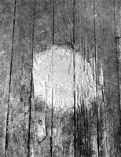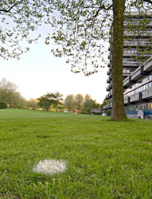  GLOSS WHITE LACQUER SPRAYED FOR 2 MINUTES AT FORTY POUND PRESSURE DIRECTLY UPON THE FLOOR  Nr. 007, 1968 | 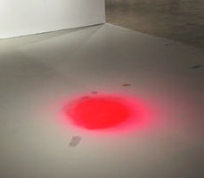  TWO MINUTES OF SPRAY PAINT DIRECTLY UPON THE FLOOR FROM A STANDARD AEROSOL SPRAY CAN  Nr. 017, 1968 [2007]
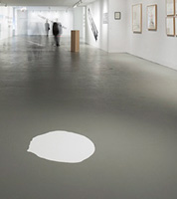  ONE PINT GLOSS WHITE LAQUER POURED DIRECTLY UPON THE FLOOR AND ALLOWED TO DRY  1968 [2007] | 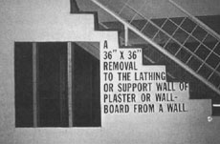  A 36" X 36" REMOVAL TO THE LATHING OR SUPPORT WALL OF PLASTER OR WALL-BOARD FROM A WALL  Nr. 021, 1968

Lawrence Weiner: Text Exhibits
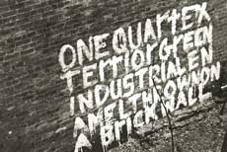  One Quart Exterior Industrial Enamel Thrown on a Brick Wall  Nr. 002, 1968 [1986] | A 36" X 36" REMOVAL TO THE LATHING OR SUPPORT WALL OF PLASTER OR WALL-BOARD FROM A WALL  Nr. 021, 1968 | 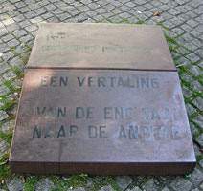  A TRANSLATION FROM ONE LANGUAGE INTO ANOTHER (EEN VERTALING VAN DE ENE TAAL NAAR DE ANDERE)  Nr. 071, 1969 [1996]
  TO SEE & BE SEEN 1972 | 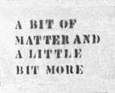  A BIT OF MATTER AND A LITTLE BIT MORE  Nr. 430, 1976 [1983] | 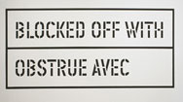  BLOCKED OFF WITH – OBSTRUE AVEC 1979
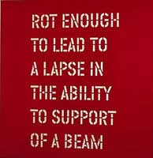  NOT ENOUGH TO LEAD TO A LAPSE IN THE ABILITY TO SUPPORT OF A BEAM 1986 | 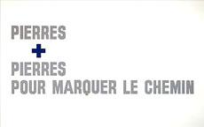  1987 | 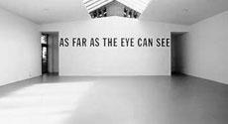  AS FAR AS THE EYE CAN SEE 1988 [2000]
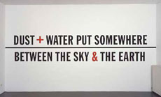  1990 | 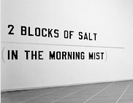  2 BLOCKS OF SALT (IN THE MORNING MIST) 1991 | 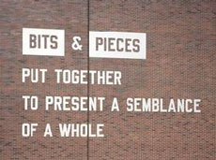  BITS & PIECES PUT TOGETHER TO PRESENT A SEMBLANCE OF A WHOLE 1991
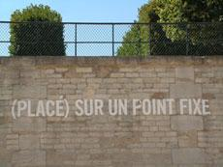  1992 | 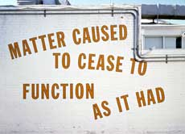  MATTER CAUSED TO CEASE TO FUNCTION AS IT HAS 1995 | 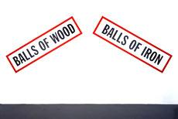  BALLS OF WOOD, BALLS OF IRON 1995
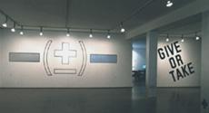  More or less / Give or take, 1997 | 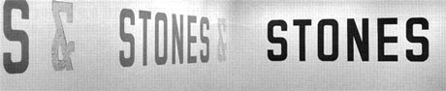  STONES & STONES & STONES, 1997
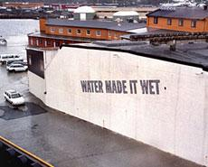  WATER MADE IT WET 1998 | 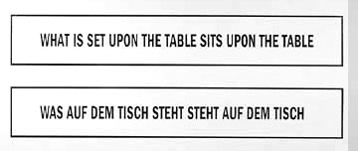  WHAT IS SET UPON THE TABLE SITS UPON THE TABLE 1999
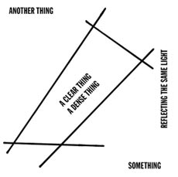  ANOTHER THING A CLEAR THING A DENSE THING SOMETHING 2000 | 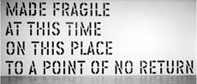  MADE FRAGILE AT THIS TIME ON THIS PLACE TO A POINT OF NO RETURN 2000 | 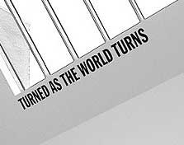  TURNED AS THE WORLD TURNS 2001
  2003 | 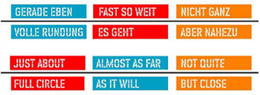  2006

Bits & Pieces Put Together to Present a Semblance of a Whole
1991

Inside & Outside of Itself
2005

Iron & Gold in the Air Dust & Smoke on the Ground
1995

Water Made It Wet
1998

- 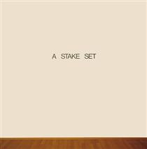
- A Stake Set
- Lawrence Weiner • 1969
- 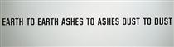
- Earth to Earth Ashes to Ashes Dust to Dust
- Lawrence Weiner • 1970
- 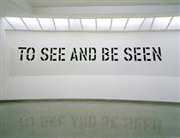
- To See and Be Seen
- Lawrence Weiner • 1972
- 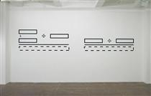
- Untitled
- Lawrence Weiner • 1991
- 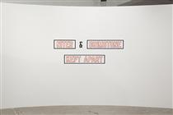
- Niter & Brimstone Kept Apart
- Lawrence Weiner • 1993
- 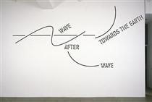
- Wave After Wave Towards the Earth
- Lawrence Weiner • 2002
- 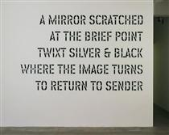
- A Mirror Scratched at a brief point twixt silver & black where the image turns to return to sender
- Lawrence Weiner • 2004
- 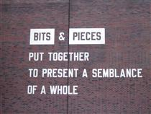
- Bits & Pieces Put Together to Present a Semblance of a Whole
- Lawrence Weiner • 2005
- 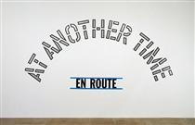
- En Route: At Another Time
- Lawrence Weiner • 2005
- 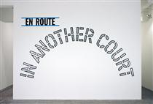
- En Route: In Another Court
- Lawrence Weiner • 2005
- 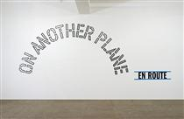
- En Route: On Another Plane
- Lawrence Weiner • 2005
- 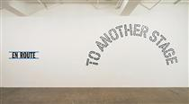
- En Route: To Another Stage
- Lawrence Weiner • 2005
- 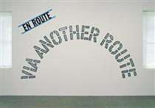
- En Route: Via Another Route
- Lawrence Weiner • 2005
- 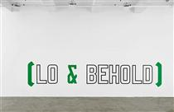
- Lo & Behold
- Lawrence Weiner • 2006
- 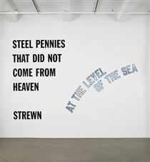
- Steel Pennies That did not come from heaven, strewn, at the level of the sea
- Lawrence Weiner • 2008
- 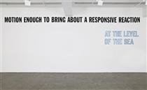
- Motion Enough to Bring About a responsive reaction at the level of the sea
- Lawrence Weiner • 2008
- 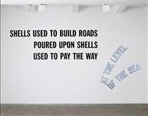
- Shells Used to Build Roads poured upon shells used to pay the way at the level of the sea
- Lawrence Weiner • 2008
- 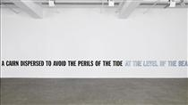
- A Cairn Dispersed to avoid the perils of the tide at the level of the sea
- Lawrence Weiner • 2008
- 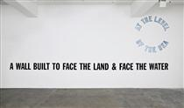
- A Wall Built to face the land & face the water, at the level of the sea
- Lawrence Weiner • 2008
- 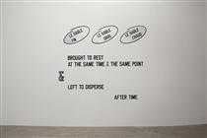
- Le sable fin...
- Lawrence Weiner • 2008
- 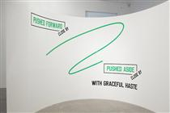
- Pushed Forward...
- Lawrence Weiner • 2009
- 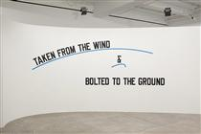
- Taken From the Wind & bolted to the ground
- Lawrence Weiner • 2009
- 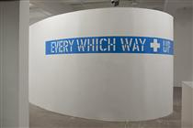
- Every Which Way + Up
- Lawrence Weiner • 2010

ONE QUART EXTERIOR GREEN INDUSTRIAL ENAMEL THROWN ON A BRICK WALL

Earth to Earth, Ashes to Ashes, Dust to Dust

SOME LIMESTONE SOME SANDSTONE ENCLOSED FOR SOME REASON

Forever and a Day

PUSH AS IF & LEFT AS IS
2012

THIS AS THAT BE THAT AS IT MAY
2012

HOWSOEVER IT SEEMS IT SEEMS SO HOWSOEVER
2012

FOUND ALONE AFTER ANY GIVEN TIME
2001

WITHIN A REALM OF RELATIVE FORM
2005

PUSHED AS IF & LEFT AS IS

STASIS AS TO VECTOR (ALL) IN DUE COURSE
2012

Paradise Lost, 2010
MOI + TOI & NOUS, 2018
Wir sind keine Enten auf dem Teich, 1990
How Much is Enough, 2017

ISLANDS IN THE STORM, 1990
AN ENTRANCE & (WITH MUCH ADO) AN EXIT (±), 2010
AT THE SAME MOMENT, 2000
ASPHALT AND LIMESTONE AND SAND KNEADED..., 2001
FLOATED ON WATER SUSPENDED AT THE POINT..., 2018
"Tit as Tat", 2013
Imaginary Realities, 1994
AFTER CROSSING THE RIVER, 2011
The salt of the earth mingled with the salt..., 1996
Mens Rea, 2013
PUSHED AS IF & LEFT AS IS, 2012
& GINITER & BRIMSTONE KEPT APART, 1992
STACKS OF SEVERED TREES LAID BESIDE A..., 2007
Concentricity Per Se, 2012
Ship to Shore, 2004–2018
Inherent Innate Tension, 2017
THE BOULDERS ON TOP RENT & SPLIT, 1987
AFTER HERE & THERE, 2014
Polaris, Wild Blue Yonder, 1990
AWAY FROM THE WIND AWAY FROM THE SUN AWAY..., 2006
AS LONG AS IT LASTS, 1992
Forever in the Flow, 2016
Situation, 2016
Consequence, 2016
MADE TO BE, 2016
SAND & STONE PUT UNDER FOOT SOME FROM HERE..., 2016
OXYGEN & ACETYLENE MADE TO WELD IRON AT A..., 2007
MANY THINGS LEFT ON THE BANKS OF A RIVER..., 2014
PUT WHERE IT WAS NOT LEFT WHERE IT IS USED..., 2000
Filofax, 2013
ABOVE BROUGHT UP SHORT CARRIED OVER THE DISTANCE, 2012
UNDER THE TOP, 2012
AROUND & AROUND HIGH & LOW, 2012
Apropos to Cul-de-Sacs, 2009
SOMEWHERE SOMEHOW FOREVER & A DAY, SOMETHING , 2008
RETURNED BENEATH THE TRACES OF THE WAY IT..., 2008
PLACED ON A POINT NOT QUITE AT THE POINT, 2009
AWAY FROM THE WIND, AWAY FROM THE SUN, AWAY..., 2006
PLACED ON THE TIP OF A WAVE, 2009
"Stars don't stand still in the sky for..., 1990
Shot to Hell..., 1996
On the Prow of a Ship, 1989, 1989
A RESPITE AT SOME POINT ASAP, 2015
“Shot to hell ...” , 1991
A SPECIFIC SPACE FILLED WITH PARTICLES OF A..., 2006
Study for One Potato Two Potato Three Potato , 1987
Drapeau for a community, from Gran Pavese –..., 1988
Edition for The Kitchen, 2020
Blue Moon Over, 2001
LOST AT SEA , 1994
Pierogi, 2010
Unter den Linden (Parkett No. 42), 1994
Water spilled from Source to Use
Easy Come, Easy Go, 1989
Porticus, 1989
Learn to read Art, 1989
IN SUCH DISARRAY AS NOT TO BE ABLE TO PUT BACK TOGETHER AGAIN, 2018
IN TANDEM WITH THE SANDS, 2018
& WITH MALICE AFORETHOUGHT, 2013
IN THE COURSE OF EVENTS, 2013
IN ALL INNOCENCE, 2013
MANY DIFFERENT THINGS IN MANY DIFFERENT PLACES AT MANY DIFFERENT TIMES, 2009
ON THE LINE OFF THE LINE, 1997
ANYTHING ADDED TO SOMETHING, 2009
FLAGS FOLDED OUT OF SIGHT OF THE BARRICADE, 1989
PLACED SOMEPLACE WITH INTENT, 2014
On Top of the Wind, 2013
WRAPPED UP IN ITSELF, 2013
ENOUGH, 2021
AN ENTRANCE & (WITH MUCH ADO) AN EXIT (±), 2010
NITER & BRIMSTONE KEPT APART, 1992

WAVES FOLDED IN SUCH A MANNER AS TO RENDER THEM DRY, 2018

GOLD SILVER PER SE EMERALDS STEEL SALT PER SE DIAMONDS MOVED CARRIED PER SE PLACED, 2001
AFTER HERE & THERE, 2014

“IN THE WAY,”
“ON THE WAY,”
“ON VIEW,”
and
“REMOVED FROM VIEW”

“Matter Caused to Cease to Function As It Had,” 1995
“Right on Top,” 2002.
SMASHED TO PIECES (IN THE STILL OF THE NIGHT) (1971)
TO SEE AND BE SEEN (1972)
AN OBJECT TOSSED FROM ONE COUNTRY TO ANOTHER (1988)
UNDER THE SUN (1999/2000)
AS TO BE IN PLAIN SIGHT (2009)
WITHIN A REALM OF DISTANCE, 2015

ANYTHING ADDED TO SOMETHING

